MACH4METAL

metalworking machinery
Transito 21,
6909 DA BABBERICH, Netherlands
Tel. + 31 (0)316 – 247123
Fax. + 31 (0)316 - 247956

Bank No : 66.52.13.883
IBAN : NL33 INGB 0665 2138 83
BIC : INGBNL2A
info@mach4metal.com www.mach4metal.com www.mach4metal.com

Heyligenstaedt 1170 x 6000 mm

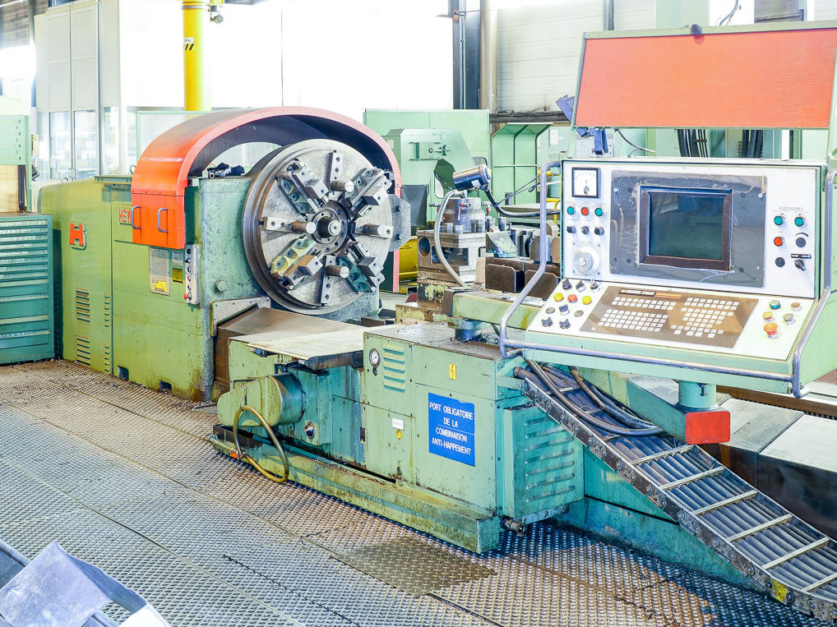
- Make : Heyligenstaedt Germany
- Typ : ND 560 En / II
- Age : 20..
- Mach.No. : 2910 02407

- Max. turning Ø over bed : 1.170
- Max. turning Ø over carriage : 760
- Centre height : 585
- Centre distance : 6.000

- Bed width :
- Bed height :
- Number off guide ways : 3
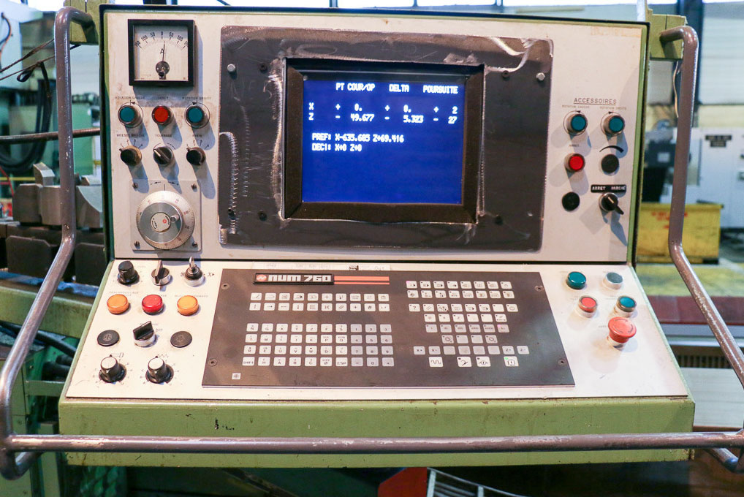

- Spindle bore : 100
- Speeds 24 x : 2 – 250
- Power : 35 kW
- Work load : 16.000 Kg

- CNC Control NUM 760

- Large tooling package
- 4 chuck Ø 1000 mm
- 1 fixed steady Ø
- 1 fixed steady Ø
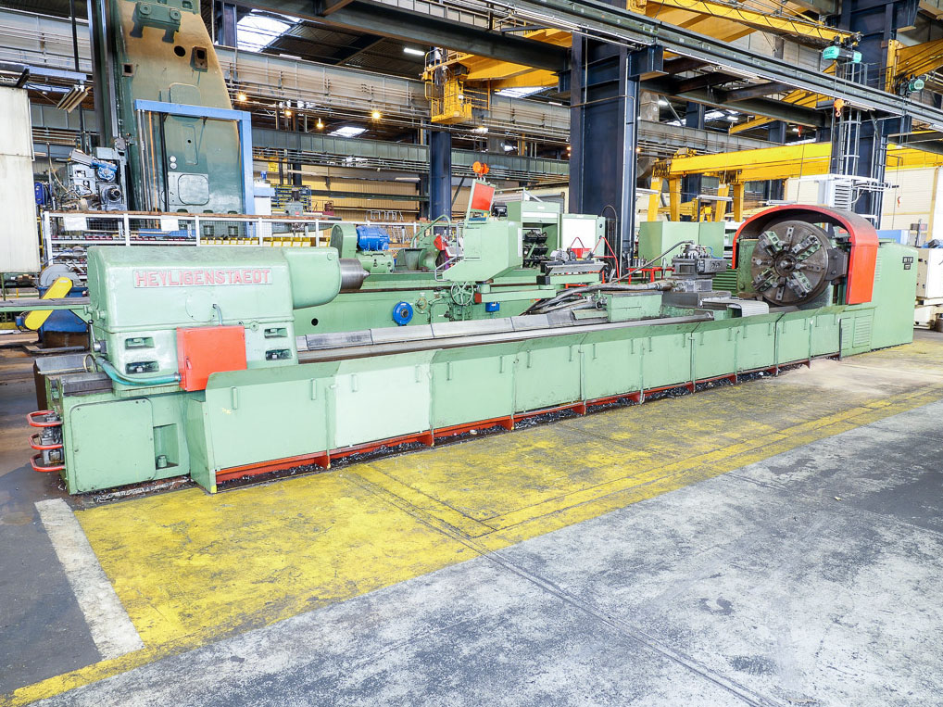
- 1 roller steady Ø

- Dimensions
- Length : 9000
- Width : 3000
- Height : 2400
- Weight :

Please Note: The above information has been obtained to the best of our ability and belief from, and from the manufacturers where possible. It is given in good faith, but its accuracy can not be guaranteed. Accordingly, it will not form a representation or constitute contractual terms. We advise you to check any vital details!

